Plane Euclidean geometry

# The coordinate plane

We start with the familiar plane of analytic geometry. Each ordered pair (PI, P2) of real numbers determines exactly one point P of the plane. The point determined by (O, O) is called the origin.

The ordered pair (PI, P2) is also referred to as the coordinate vector of P. Although mathematically equivalent, the words "point" and "vector" have different connotations. A vector is usually thought of as a line segment directed from one point to another. We may think of the vector (PI, P2) as the line segment beginning at the origin O and ending at P.. We shall regard the words "point" and "vector" as interchangeable, using whichever suggests the more appropriate picture. The set of all vectors is denoted by

# The vector space

If x = (x1, x2) and y = (h, h), then we define



If c is a real number and x is a vector, then we define

cx = (cx1, cx2)

These operations are called vector addition and scalar multiplication, respectively. In particular, if c = -1, the vector cx is denoted by -x.

The vector O = (O, O) is called the zero vector. The operations of vector addition and scalar multiplication enjoy the following familiar algebraic properties:

Theorem 1. For all vectors x, y, and z, and real numbers c and d,

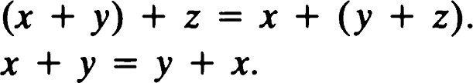

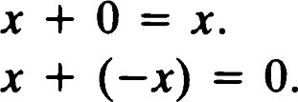

1. Ix = x.
2. c(x + y) cy.

vii. (c + d)x = cx+dx

viii. c(dx) = (cd)x.

# The inner-product space R

Given two vectors x and y, we define

( X , y) = X IYI + X2Y2.

The number (x, y) is called the inner product of x and y. It is sometimes also called the dot product or scalar product of x and y.

The following identities concerning the inner product may be easily checked.

Theorem 2.

i.  = (x, y) + (x, z) for all x, y, z e R2 . ii. (x, cy) = c<x, y) for all x, y E R2 and all c e R. iii. = (y, x) for all x, y e R2 .

If (x, y) = O for all x e R2 , then y must be the zero vector.

Remark: Theorem 1 says that R2 is a vector space. Theorem 2 says that the inner product is bilinear, symmetric, and nondegenerate. See Appendix D for further discussion of these notions.

For any vector x e R2 we define the length of x to be

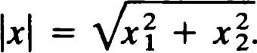

Note that

Ix1 2 = (x, x),

so that length and inner product are intimately related.

Theorem 3. The length function has the following properties:

1. IXI 0 for all x e R2 .
2. If IXI = 0, then x = O (the zero vector).
3. lcxl = lcllxl for all x e R2 and all c E R.

We now state and prove a less immediate property of the inner-product function and its consequence for length. 9 Theorem 4 (Cauchy—Schwarz inequality). For two vectors x and y in R2 we have

Ixllyl•

Equality holds if and only if x and y are proportional.

Proof: We restrict our attention to nonzero vectors x and y, the assertion being obviously true when either x or y is zero.

Consider the real-valued function f defined by

= Ix + typ for t e R.

Using the properties stated above, we observe that f(t) is nonnegative for all t and that f(t) assumes the value O if and only if x is a multiple of y.

On the other hand, f is a polynomial of degree 2. Specifically,

= IX12 + 2t<X, y) + t21y12 (1.1)

and as such remains nonnegative only if (x, y)2 < Ix1 2 1y1 2 ; that is, I(x,

 Ixllyl•

In addition, f(t) assumes the value zero only if I(x, y) I = Ixllyl. Thus, Ixllyl if and only if x and y are proportional.

Corollary. For x, y e R2 ,

 (1.2)

 Equality holds if and only if x and y are proportional with a nonnegative proportionality factor.

proof:

## 2 IX12 + 2 (x, y) + I y12

 IX12 + 21xllyl + ly1 2 (1.3)

= + lyl)2, hence, Ix + yl + lyl.

If equality holds here, then we must have

= IYI•

From our work on the Cauchy—Schwarz inequality, we see that x and y must be proportional. But x = cy leads to cly12

and

Ixllyl = I c llyllyl = l c IIy1 2 .

Thus,c must be equal to lcl; hence, c O.

# The Euclidean plane E2 Lines

The plane has both algebraic and geometric aspects. When we think of the algebraic properties, we are thinking of the vector properties of R2

We now turn to the geometric concept of distance. If P and Q are points, we define the distance between P and Q by the equation d(P, Q) = IQ - PI.

The symbol E2 will be used to denote the set R2 equipped with the distance function d.

The concept of distance is a fundamental one in geometry. We will now derive the most important properties of distance. They are stated in the following theorem.

Theorem 5. Let P, Q, and R be points of E2 . Then



ii. d(P, Q) = O if and only if P = Q. iii. d(P, Q) = d(Q, P).

iv. d(P, Q) + d(Q, R) d(P, R) (the triangle inequality).

Proof: Because d(P, Q) = IQ — PI = — = IP — Q, the first three properties follow from Theorem 3. The fourth property is equivalent to showing that

IQ - PI + IR - QI - P) + (R - = IR - PI.

This, of course, follows from the corollary to Theorem 4. Furthermore, equality holds if and only if Q — P = u(R — Q) for some nonnegative number u. In the next section we will see that this implies that P, Q, and R are collinear.

# Lines

A line in analytic geometry is characterized by the property that the vectors joining pairs of points are proportional. We define a direction to be the set of all vectors proportional to a given nonzero vector.

For a given vector v let

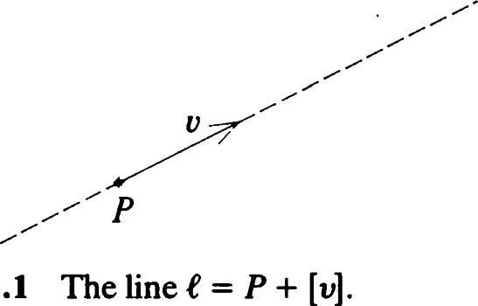

Figure

1.1

[v] = {tvl t R}.

If P is any point and v is a nonzero vector, then

 (1.4)

is called the line through P with direction [v]. See Figure 1.1. We also write (1.4) in the form

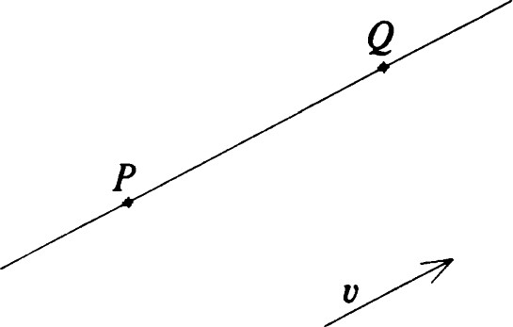

Figure 1.2 The line PQ and a direction vector v.

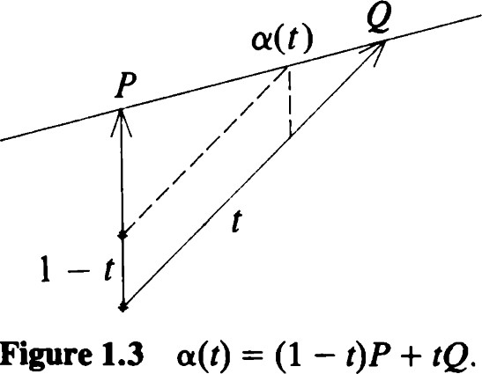



When e = P + [v] is a line, we say that v is a direction vector of e.

If e is a line and X is a point, there are many phrases used to express the relationship X e e. The following are synonymous:

i.

ii. e contains X. iii. X lies on e.

1. C passes though X.
2. X and e are incident. vi. X is incident with e. vii. e is incident with X.

Remark: In axiomatic geometry one usually takes points and lines as fundamental objects and incidence as a fundamental relation. Then an incidence geometry would consist of sets and g and a relation in x g. The relation is assumed to satisfy certain properties from which other properties of the axiomatic system are deduced. See Greenberg [161. We are being more specific here, but our propositions occur as axioms or propositions in axiomatic developments of plane geometry.

A fundamental property of a line is that it is uniquely determined by any two points that lie on it. Thus, it is important to mention the following:

Theorem 6. Let P and Q be distinct points of E2. Then there is a unique line containing P and Q, which we denote by PQ.

Proof: Let v be a nonzero vector. The line P + [VI passes through Q if and only if Q — P e [v]. This means that [Q — PI = [v]. Hence, the line P + [Q — PI is the unique line required. See Figure 1.2.

Thus, a typical point X on the line e = PQ is written

 (1.5)

(See Figure 1.3 for a vector addition interpretation.) This equation may be regarded as a parametric representation of the line. As t ranges through the real numbers, a(t) ranges over the line. The parameter is related to distance along e by the formula a(t2)) = lh - tlllQ - Pl. (1.6)

If X = (1 — t)P + tQ, where O < t < 1, we say that X is benveen P and Q. This algebraic characterization of betweenness is equivalent to the following geometrical one.

Theorem 7. Let P, X, and Q be distinct points ofE2 . Then X is between P and Q if and only if

d(P, X) + d(X, Q) = d(P, Q).

Proof: Suppose first that X is between P and Q. Then for some t e (O, 1),



Then - PI = It(Q - P)! -- tIQ -

Also, d(x, Q) = IQ -( 1 - t)IQ - PI,

hence,

d(P, X) + d(X, Q) = tIQ - PI + (1 - t)IQ - PI = IQ - PI = d(P, Q).

Conversely, suppose that X is a point of E2 satisfying d(P, X) + d(X, Q) = d(P, Q). As we saw in Theorem 5, there is a positive number u such that



Solving for X gives

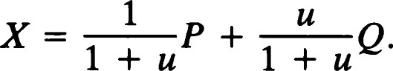

Setting t = u/(l + u), we see that O < t < 1, while 1so that X = (1 - + tQ. Thus, Xis between P and Q.

Remark: Theorem 7 is illustrated in Figures 1.4 and 1.5.

Let P and Q be distinct points. The set consisting of P, Q, and all points between them is called a segment and is denoted by PQ. P and Q are the end points of the segment. All other points of the segment are called interior points.

If M is a point satisfying

d(P, M) = d(M, Q) = åd(P, Q),

then M is a midpoint of PQ. It follows easily from Exercise 8 that each segment has a unique midpoint, namely,



If two lines C and m pass through a point P, we say that they intersect at P and P is their point of intersection. From this point of view we restate part of Theorem 6.

Lines

x

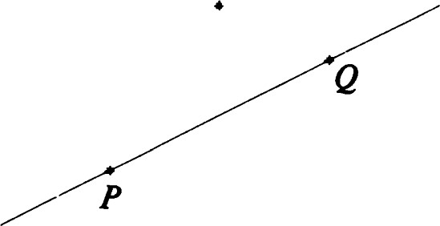

Figure 1.4 + d(X, Q) > d(P, Q). X is not between P and Q.

Figure 1.5 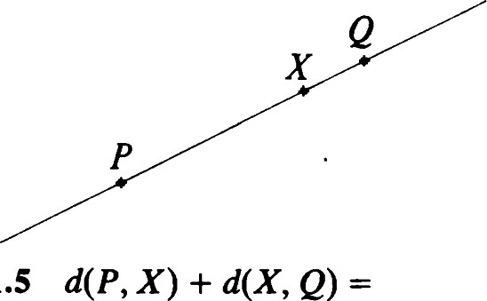d(P, Q). X is between P and Q.

Theorem 8. Two distinct lines have at most one point of intersection.

As we shall see later, two lines in E2 may have no point of intersection at all.

If three or more lines all pass through a point P, we say that the lines are concurrent. If three or more points lie on some line, the points are said to be collinear.

# Orthonormal pairs

Two vectors v and w are said to be orthogonal if (v, w) = O. It is frequently desirable to have a vector available that is orthogonal to a given vector. If v (VI, v2), we define vi = (—v2, VI). Clearly, v and vi are orthogonal and have the same length. We also easily see that



A vector of length 1 is said to be a unit vector. A pair {v, w} of unit orthogonal vectors is called an orthonormal pair.

Theorem 9. Let {v, w} be an orthonormal pair of vectors in R2 . Then for all x e R2 ,

x = (x, v)v + (x, w)w.

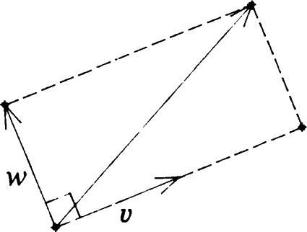Proof: Because v and w are linearly independent, they form a basis for R2 (see Appendix D). Thus, for any x e R2 , there exist unique constants and x p such that x = Xv + PW. But then, using the fundamental properties of the inner product, we get

and

p. Figure 1.6 Theorem 9. x = (x, v)v+ (x, w)w.

 Remark: Theorem 9 is illustrated in Figure 1.6.

# The equation of a line

If e is a line with direction vector v, the vector vi is called a normal vector to C. Clearly, any two normal vectors to the same line are proportional. We now derive a characterization of a line in terms of its normal vector. See Figures 1.7 and 1.8.

Theorem 10. Let P be any .point and let {v, N} be an orthonormal pair of vectors. Then P + [VI = {xl<x - P, N) = 0}.

Proof: By Theorem 9 we have the identity



for any point X in R2 . We show that X lies on the line P + [VI if and only if



First, suppose that X = P + tv for some real number t. Then



Conversely, if (X — P, N) = O, the identity reduces to



so that



Corollary. If N is any nonzero vector, {X I (X — P, N) = O} is the line through P with normal vector N and, hence, direction vector NI

Proof: Just observe that (X — P, N) = O if and only if (X — P, MINI) = O and apply the theorem.

We recall from elementary analytic geometry that {(x, y)lax + by + c = O} should represent a line, provided that a2 + b2 * 0. This fits into our scheme as follows:

Theorem 11. Let a, b, and c be real numbers. Then {(x, y)lax + by + c = O) is

i. the empty set if a = O, b = O, and c * O, ii. the whole plane R2 if a = O, b = 0, and c = O, iii. a line with normal vector (a, b) otherwise.

Proof: Cases (i) and (ii) are obvious. Consider now the case where a2 + b2 * O. One can check that the set in question is not empty. In fact, at least one of the points ( —c/a, 0) and (O, —c/b) must be defined and satisfy the equation.

Let P = (Xl, h) be any point satisfying the equation. Then c

—(axl + byo. Thus ax + by + c = 0 if and only if a(x — Xl) + b(y — h) = O. Letting N = (a, b), we see that the set in question is just the line through P with normal vector N.

## The equation of a line

x

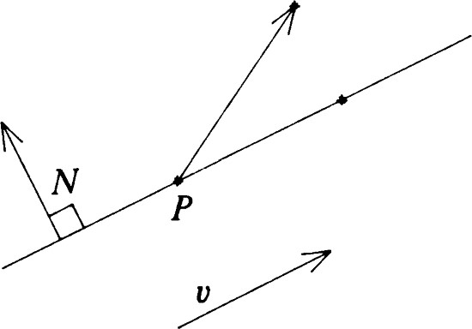

Figure 1.7 (X — P, N) * O. X does not lie on e = P + [v].

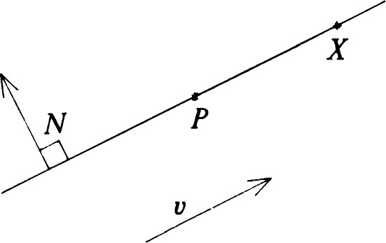

Figure 1.8 (X- P, N) = O. X lies on



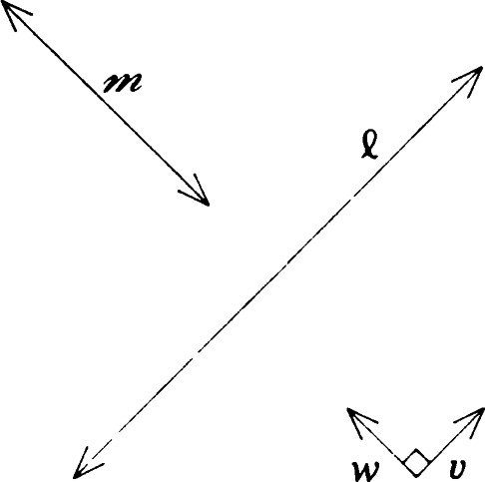

Figure 1.9 Perpendicular lines and their orthonormal direction vectors.

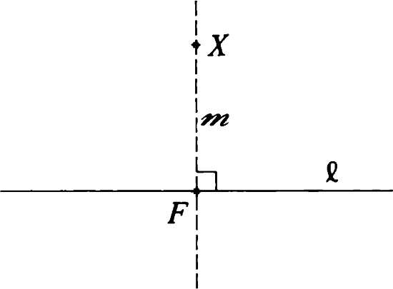

Figure 1.10 Dropping a perpendicular to e from X.

# Perpendicular lines

Two lines C and m are said to be perpendicular if they have orthogonal direction vectors. In this case we write C i m. Two segments are perpendicular if the lines on which they lie are perpendicular.

An important manifestation of perpendicularity is the famous theorem of Pythagoras.

Theorem 12 (Pythagoras). Let P, Q, and R be three distinct points. Then IR — P1 2 = IQ — P1 2 + IR — Q1 2 if and only if the lines QP and RQ are perpendicular.

Proof: We recall formula (1.3):

2 = IX12 + 2<x, y) + ly12.

We note that Ix + y1 2 = Ix1 2 + ly1 2 if and only if (x, y) = 0. Now put x = Q — P and y = R — Q. We see that x + y = R — P, and, hence, IR - pp = IQ - pp + IR - Q1 2 if and only if (Q - P, R - Q) = O. This means that the segment PQ and the segment QR are perpendicular. 

The next property of perpendicular lines is more evident intuitively than Pythagoras' theorem but more difficult to prove. See Figure 1.9.

Theorem 13. If i m, then e and m have a unique point in common.

Proof: Let C = P + [v] and m = Q + [w]. We may assume that vand w are unit vectors, so that {v, w} is an orthonormal set. We write



and, hence,



Setting

F = P - (P - Q,  (P - Q, w)w,

we see that F lies on both C and m.

F is the only common point, because if there were two, by Theorem 8 the lines would have to coincide.

This result allows us to obtain a result motivated by a construction of Euclid.

Theorem 14. Let X be a point, and let C be a line. Then there is a unique line m through X perpendicular to C. Furthermore,

i. 4-n = X + [N], where N is a unit normal vector to e; ii. e and m intersect in the point F = X — (X — P, N)N, where P is any point on e; iii. d(x, F) = - P, N)I.

Remark: The construction of when e and X are given is called erecting a perpendicular to e at X if X happens to lie on e. Otherwise, it is called dropping a perpendicular to e from X. In this case the unique point of intersection of e and is called the foot F of the perpendicular. Theorem 14 is illustrated in Figures 1.10 and 1.11.

Theorem 15. Let e be any line, and let X be a point not on e. Let F be the foot of the perpendicular from X to e. Then F is the point of e nearest to X. (See Figure 1.12.)

Proof: Let P be any point on e. Because PF L FX, Pythagoras' theorem gives Ix - pp = Ix - F1 2 + IF - pp. Thus, Ix - pp Ix - F1 2 with equality if and only if P = F.

Definition. The number d(X, F) is called the distance from the point X to the line e and is written d(X, C).

Remark: d(X, e) is the shortest distance from X to any point of e.

Corollary. Let e be a line with unit normal vector N. Let X be any point of

R2 . If P is any point on e, then d(X, e) = - P, N)I.

We now present another useful construction involving perpendicularity. Let PQ be a segment. The line through the midpoint M of PQ that is perpendicular to PQ is called the perpendicular bisector of the segment PQ. See Figure 1.13.

Remark: The perpendicular bisector consists precisely of all points that are equidistant from P and Q.

# Parallel and intersecting lines

Two distinct lines e and are said to be parallel if they have no point of intersection. In this case we write e Il n.

In light of the exercises for the section on lines, if e is any line, P is any point on e, and v is any direction vector of e, then e = P + We have the following criterion for parallelism.

## Parallel and intersecting lines

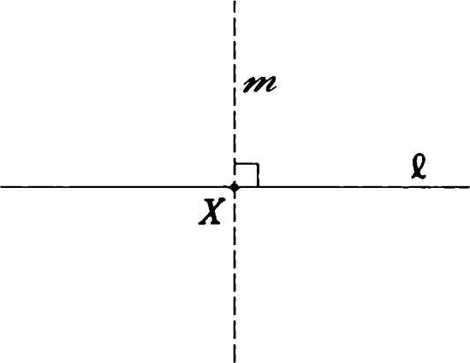

|  |  |
| --- | --- |
| Figure 1.11 eat X. | Erecting a perpendicular to  x |

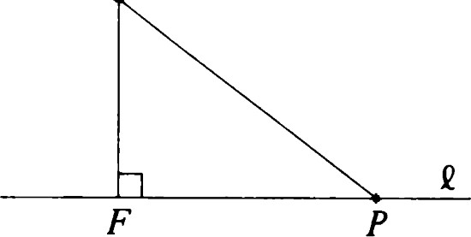

|  |  |
| --- | --- |
| Figure 1.12  x. | F is the point of e closest to |

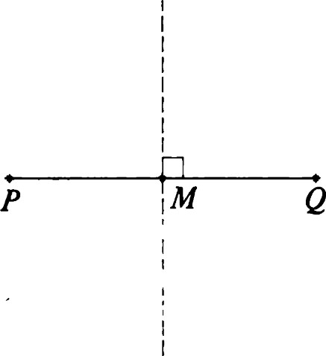

Figure 1.13 The midpoint and perpendicular bisector of a segment. 2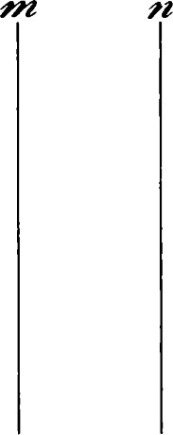

|  |  |
| --- | --- |
| Figure 1.14 e Il m, m n, and |  |

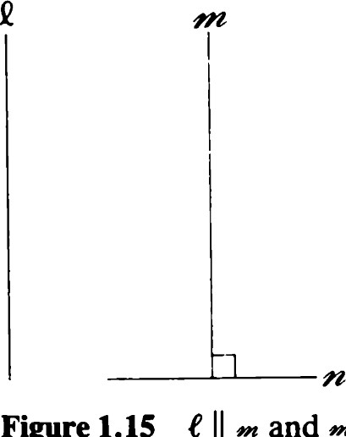Figure 1.15 e Il and -L imply

2

|  |  |  |
| --- | --- | --- |
|  |  | x |

Figure 1.16 e -L n, m -L n, and Il m.



Theorem 16. Two distinct lines e and m are parallel if and only if they have the same direction. (Recall that the direction of a line P + [v] is the set [VI.)

Proof: Suppose that e and m have a common point F. We may write e = F + [v] and m = F + [w] for nonzero vectors v and w. Because e and m are distinct, [v]

Conversely, suppose that e and have different directions [v] and [w]. Let P be any point of e, and let Q be any point of m. Because v and w are not proportional, there exist numbers t and s such that P — Q = tv + sw. (See Appendix D.) This means that P — tv = Q + sw. Let F = P — tv = Q + sw. Then Fis a common point of e and m.

Parallel lines come in families, one for each direction. A line m perpendicular to one member e of the family is also perpendicular to all the others. Thus, it is possible to parametrize the family by the real numbers, essentially by measuring distance along m. Although these facts are intuitive and familiar, it is necessary to point them out explicitly here in order to compare them to the analogous situations in non-Euclidean geometries.

We leave the proofs of these to the exercises. Cases (i)—(iii) are illustrated in Figures 1.14—1.16, respectiv.ely. Figure 1.16 also illustrates Theorem 18.

Theorem 17.

i. If Il m and Il n, then either e = n or e Il n. ii. If e Il and m i n, then e -L n.

iii. If e -L n and m -L n, then e Il m or e = m.

Theorem 18. Let e and m be parallel lines. Then there is a unique number d(t, m.) such that d(X, C) = d(Y, m) = d(e, m

for all X e m and all Y e e. In fact, if N is a unit normal vector to e and m, then for any points X on m and Y on C,



Thus, parallel lines remain "equidistant." Intersecting lines, on the other hand, behave as follows:

Theorem 19. Let e be any line, and let m be a line intersecting e at a point P. Let v and w be unit direction vectors of C and m, respectively. Let a(t) P + tw be a parametrization of m. Then d(a(t), e) = It" (w, v i )l. Thus as X ranges through m, d(X, C) ranges through all nonnegative real numbers, each positive real number occurring twice. See Figure 1.17.

|  |  |
| --- | --- |
| Reflections  Any subset of the plane is called a figure. Naturally some figures are more | Reflections |
| Figures with symmetry most | m |

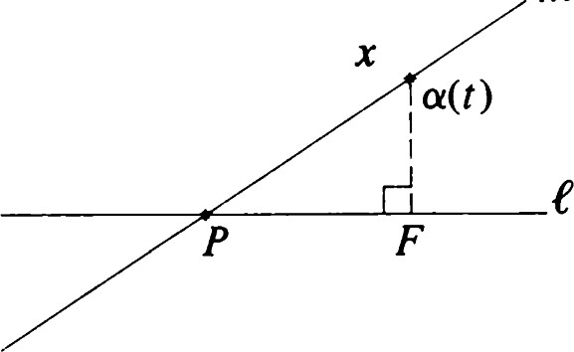interesting than others. a high degree of are interesting, not only because of aesthetic considerations but also because they occur in nature. Snowflakes, molecules, and crystals are three examples of objects with symmetric cross sections.

The simplest kind of symmetry that a plane figure can have is symmetry about a line. See Figure 1.18. We now formulate this notion precisely. Let e be a line passing through a point P and having unit normal N. Two points X and X' are symmetrical about e if the midpoint of the segment XX' is the foot F of the perpendicular from X to e. See Figure 1.19. In other words, X

and X' are symmetrical about e if we have Figure 1.17 d(a(t), F) = It'l (w, vi )l.



By Theorem 14 this means that

åx + 4X' = x- (x - P, N)N, 2

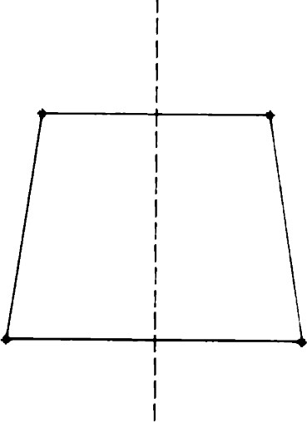 = 4X - (X - P, N)N,

X' = X- - P, N)N.

In order to consider symmetry about various lines, it is convenient to adopt a dynamic approach by expressing the relationship between X and X' in terms of a transformation that takes X to X'.

Definition. For a line e the reflection in C is the mapping Oe of E2 to E2

defined by Figure 1.18 A figure that is symmetric

about the line e. oex = x- 2K x - P, N)N,

where N is a unit normal to e and P is any point of e.

|  |
| --- |
| x |
|  |

If is a figure such that Oe F = F, then we say that is symmetric about e. The line e is called a line of symmetry or axis of symmetry of F.

We now investigate some of the properties of reflections.x'

Theorem 20.

i. d(OeX, oeY) = d(X, Y) for all points X, Y in E2 . ii. neoex = x for all points X in E2 . iii. oe: E2 -9 E2 is a bijection.

proof:

Figure 1.19 X and X' are related by

i. oex - oeY = X- Y- - Y, N)N. Thus, reflection in the line e.

IOeX-OeYP =

= Ix - Y12.

Write oex = X - 2kN, where = (X - P, N). Then

neoex = X - 2XN - 2K X - 21\N - P,

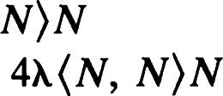

+

## = X - 2XN - 2K X - P,

= X - 2XN - 2XN + 4XN

iii. We first show that Oe is injective. If OCX = OeY, then OeOeX = OeOeY and X = Y, by (ii). To show that Oe is surjective, let Y be any point of E2 . Let X = OeY. Then OCX = Y, so that Yis in the range of

Theorem 21. OCX = X if and only if X e e.

Proof: X- 2K X - P, = X if and only if (X - P, = O; that is, (X — P, N) = 0. The statement now follows from Theorem 10.

Remark: A fixed point of a mapping T is a point X satisfying TX = X. Thus, Theorem 21 says that the fixed points of a reflection are those which lie on its axis.

Remark: Theorem 20 shows that reflections are involutive distancepreserving bijections. We study distance-preserving bijections (isometries) in the next section. To say that a mapping T is involutive means T2 = TT = I, the identity mapping of E2 . (See also Appendix B.) 2

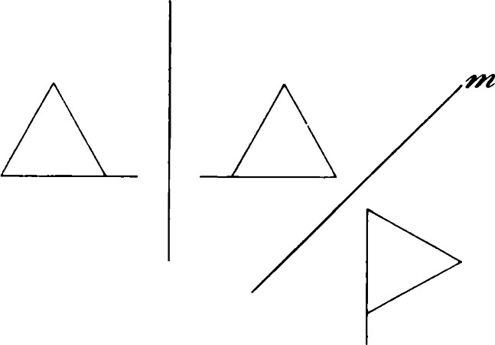Congruence and isometries

If is any figure and Oe is any reflection, then Oe is called the mirror image of in the line e. The figure and its mirror image are observed to have the same "size" and "shape." If 0m is a second reflection, then Figure 1.20 Successive reflections 0m Oe Fis again the same size and shape as 9. (See Figure 1.20.) One may o„oe. think of moving 9 "rigidly" in the plane so that it coincides with Om Oe F. The key property that makes precise our intuitive notions of size, shape, and rigid motion is that the distance between each pair of points on is equal to the distance between the corresponding pairs of points on OMOe9. We introduce the general concept of distance-preserving mapping or isometry as follows:

Definition. A mapping TofE2 onto E2 is said to be an isometry iffor any X and Y in E2 ,

d(TX, TY) = d(X, Y).

Definition. Two figures and are congruent if there exists an isometry T such that T91 = 92.

We showed in the previous section that every reflection is an isometry. Although not every isometry is a reflection, we shall see later that every isometry is the product (composition) of at most three reflections. Thus, reflections are the basic building blocks of isometries.

Every isometry Tis a bijection of E2 onto E2 . In fact, if TX = TY, then

O = d(TX, TY) = d(X, Y),

so that X = Y. Therefore, the inverse mapping E l exists. In fact, E l is also an isometry because d(T-lX, T-I Y) = d(TT-lX, TT-I Y) = d(X, Y).

Furthermore, if T and S are isometries, then d(TSX, TSY) = d(sx, SY) = d(X, Y).

We now state these results formally.

Theorem 22.

i. If T and S are isometries, so is TS. ii. If T is an isometry, so is T-l iii. The identity map I of E2 is an isometry.

In other words, the set of all isometries is a group called the isometry group of E2 . It is denoted by J(E2).

# Symmetry groups

Let 9 be a figure in E2 . Then the set

90 (f) = {T e  F}

is a subgroup of J(E2) called the symmetry group of 9. The fact that g(F) is a subgroup can be easily verified. The size of the symmetry group of is a measure of the degree of symmetry of the figure. We shall show, for example, in a later chapter that an equilateral triangle (Figure 1.21) has a symmetry group of order 6 generated by reflections in the three medians. The isosceles triangle ABC (Figure 1.22) has a symmetry group of order 2 generated by reflection in the median AM. The circle has an infinite symmetry group generated by reflections in all diameters. For an elementary discussion of symmetry groups, see Alperin [2].

## Symmetry groups

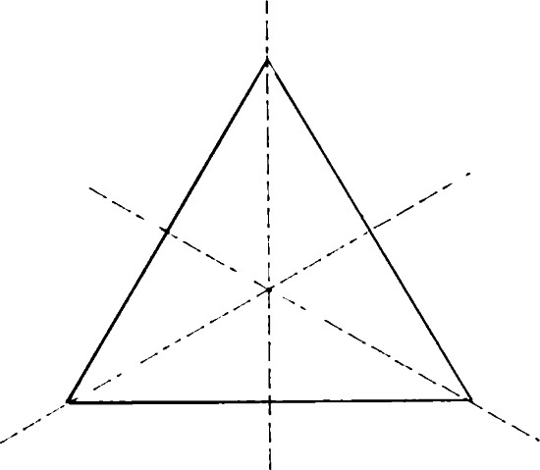

Figure 1.21 An equilateral triangle and its axes of symmetry.

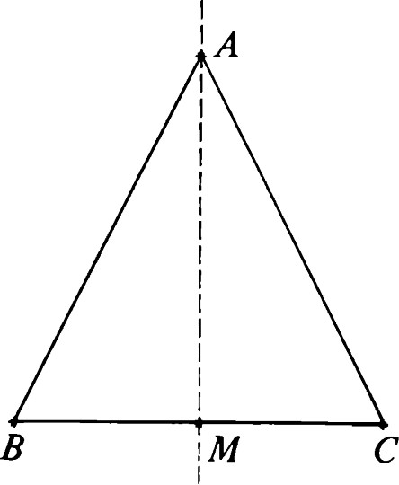

Figure 1.22 An isosceles triangle and its axis of symmetry.

# Translations

Is there a simple way to describe the product of two reflections? In this section we answer that question affirmatively in the case where the axes of reflection are parallel.

Specifically, if m and n are parallel lines, we may choose P arbitrarily on m and choose Q to be the foot of the perpendicular from P to n. Then if N is a unit normal vector to (and hence to n), we get

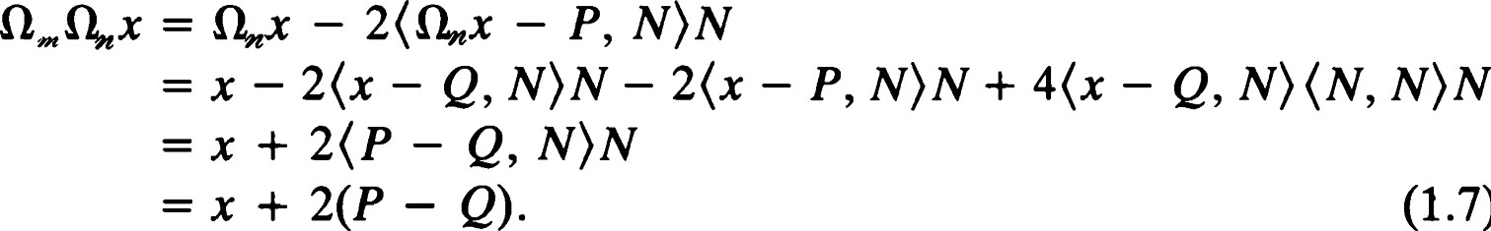

(1.7)

The last step uses the fact that PQ is perpendicular to m.

Definition. Let e be any line, and let m and n be perpendicular to e. The transformation is called a translation along e. If m * n, the translation is said to be nontrivial.

Remark: When two lines in E2 are perpendicular to e, they are, of course, parallel. On the other hand, when two lines are parallel, there is a line (in fact, infinitely many lines) perpendicular to both. In the geometries we will study later in this book, these properties will fail to be true. In the projective plane, for example, two lines can be perpendicular to a third line but still not be parallel. In the hyperbolic plane, on the other hand, there are parallel lines with no common perpendicular. Thus, if our terminology here seems more specific than necessary, it is being set up so that it will be applicable to the other geometries we study as well.

We now see that in the Euclidean plane, a translation does not determine a line uniquely, although it does determine a parallel family. In the exercises you will be asked to prove the following:

Theorem 23. Let T be a translation along e. If C' is any line parallel to e, then T is also a translation along C'.

We also observe that each translation along e has the effect of adding a direction vector of e to each vector in the plane.

Theorem 24. Let T be a nontrivial translation along e. Then e has a direction vector v such that

Tx = x + v (1.8)

for all x e E2 . Conversely, if v is any nonzero vector and e is any line with direction vector v, then the transformation T determined by (1.8) is a translation along e.

Proof: Let N be a unit direction vector for e. Let P be an arbitrary point of E2 . Let a and ß be lines perpendicular to e. (See Figure 1.23.) Let a and b be the unique numbers such that P + aN e a and P + bN e ß. Our formula (1.7) becomes



= x + 2(a — b)N.

If T * I, we must have a * b, so that 2(a — b)N is the required direction vector.

Conversely, suppose that for each real number we define a mapping Tx by

Thx = x + RN. (1.9)

If a and b are any two numbers such that = 2(a — b), we construct  = P + aN + [NL ] and ß = P + bN + [Ni ] and observe that Tx = OaOß.

We now investigate the group of all isometries generated by reflections in lines perpendicular to e. First we must introduce some new terminology.

Definition. The set of all lines perpendicular to a given line e in E2 is called a pencil of parallels. The line e is a common perpendicular for the pencil. See Figure 1.24.

We note that taking any line in E2 together with all lines parallel to would be an equivalent construction.

So far we have discovered that the product of two reflections in lines of a pencil of parallels is a translation along the common perpendicular e. We now investigate further the algebraic structure of the set of isometries formed by reflections of such a family.

We begin with the translations. We denote the set of all translations along e by TRANS(C).

Theorem 25. TRANS(C) is an abelian group isomorphic to the additive group of real numbers.

Proof: We adopt the notation of Theorem 24. Then

Tp(x) = Tx(x + PN) = x + RN = x + (p + = Tp+kX.

## Translations

|  |  |  |
| --- | --- | --- |
| x | x' | x" |
|  |  |  |

Figure 1.23 OaOß is the translation along e by an amount equal to twice d(a, ß). Three successive positions X, X' , and X" of a typical point are shown.

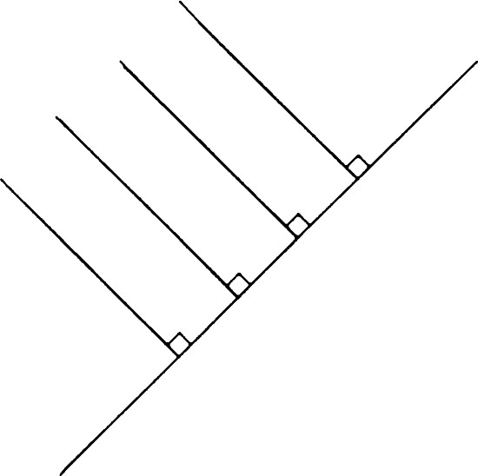2

Figure 1.24 A pencil of parallels with common perpendicular e.

Similarly ,

Tk(x) = Tk+p(x).

Because X + = + X, translations along e commute.

Further, setting = O yields To = I and Tx o T-x I, so that (TO-I

Thus, TRANS(C) is a subgroup of J (E2). Furthermore, the mapping k -9 Tx of R to TRANS(C) is an isomorphism. This is seen by observing that TO = 1, TX -l = T-x, and =

Let be the pencil of all lines that are perpendicular to a line C. We denote by REF(") the group generated by all reflections of the form O,n, where m e 9. In other words, REF(9) is the smallest subgroup of J(E2) containing all such 0m. In turn, TRANS(C) is a subgroup of REF(").

In order to discuss the algebra of REF(9), we need to be able to compute the product of any number of reflections in the family determined by 9. We already know that in our notation, OaOß = TX.

We now take three lines, a, ß, •y, of corresponding to the numbers a, b, and c. Then

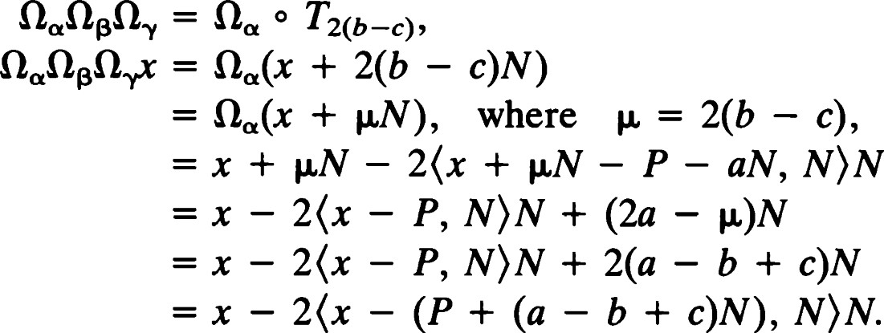

We recognize the right side as the formula for reflection in the line b e passing through the point P + dN, where d = a — b + c.

Thus, the product of three reflections in lines of is a fourth reflection in a line of the same pencil 9. This is our first instance of a three reflections theorem, which plays such an important role in classifying the isometries of plane geometries.

Theorem 26 (Three reflections theorem). Let a, ß, and be three lines of a pencil with common perpendicular e. Then there is a unique fourth line of this pencil such that



There are many ways in which a given translation may be represented as the product of two reflections. Using the three reflections theorem, we can exhibit this flexibility precisely.

Theorem 27 (Representation theorem for translations). Let T = OaOß be Translations any member of TRANS(C). If m and n are arbitrary lines perpendicular to e, there exist unique lines m' and n' such that

T = = on,on.

Proof: Apply the three reflections theorem to m, a, and to produce a unique line m' such that O„OaOß = 0„,. Then multiplying both sides by yields OaOß = The line n' is obtained analogously.

Corollary. Every element of REF(") is either a translation along e or a reflection in a line of 9.

Proof: This is clear from the following group multiplication table, which summarizes the facts we have established.

|  |  |
| --- | --- |
|  |  |
|  | 2(a-b) |

Here, we have temporarily indexed the reflections O by numbers rather than lines. Thus, for example, Oa is short for Oa, where a = P + aN +

Let v be any vector in E2 . We define Tv, the translation by v, by

Tt,x = X + V.

(If v — I, and we have the trivial translation.) Although all translations arise in the manner we have described, it is possible to discuss in an elementary way the product of two translations that are not along the same line. We get

Theorem 28. The set eT(E2) of all translations is an abelian subgroup of J(E2).

Proof: The following equations are easy to verify and imply the conclusions of the theorem:

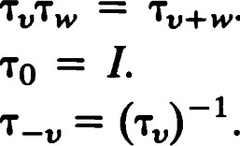

Tv+w.

Corollary. eT(E2) is isomorphic to the group R2 with vector addition.

# Rotations

We now investigate the product of reflections in two intersecting lines.

Let e = P + [v] be a line with unit direction vector v. There is a unique real number e e ( —T, such that

 = (cos 0, sin 0). (See Theorem IF.)

The unit normal v can be written as

N = ( —sin 0, cos 0).

We now try to express Oe in terms of e. First note that

= x - - P, N)N,

- P = x - P - - P, N)N.

Let Co be the line through 0 with direction [v]. Then

Oeox = x - 2<x, N)N.

Thus, we see that

Oex - P = oeo(x - P),

or

Oex = oeo(x - P) + P.

In other words,

 (1.10)

We first deal with Oe and use (1.10) to return to the original situation.

For any x note that

 = —Xl sin 0 + X2 cos 0.

Thus, writing our vectors as column vectors, we get

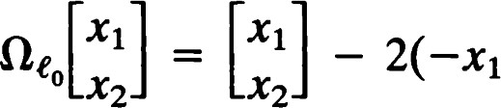—sin 0 sin 0 + x2 cos 0) cos 0

— 2 sin2 0)XI + (2 sin e cos e)X2

(2 sin e cos O)XI + (1 — 2 cos2 0)X2

cos 20 sin 20 Xl

(1.11) sin 20 —cos 20 X2

In other words, Oe : R2 -9 R2 is linear. We denote its matrix (see Appendix D) by the symbol ref 0. This matrix represents reflection in the line through the origin whose direction vector is (cos 0, sin 0):

cos 20 sin 20

ref e =



26 sin 20 —cos 20

We now investigate the matrix algebra of these reflections. First we consider another line m through P and the associated line mo. Then if (cos 4, sin 4) is a direction vector of m,

 cos — 4) —sin — 4)

ref 0 ref

sin — 4) cos — 4)

We have a special symbol, rot 0, for a matrix of the form

cos 0 —sin e rot 0 —

sin e cos 0

Because this linear mapping takes the standard unit basis vector El to v = (cos 0, sin 0) and takes to vi = (—sin 0, cos e), it is reasonable to think of rot e as a rotation by e radians in the positive sense. We must keep in mind, however, that definitions of angle, radians, or sense have not yet been given. We now define rotation in such a way that rot 0 is a rotation about the origin.

Definition. If a and are lines passing through a point P, the isometry OaOß is called a rotation about P. (See Figure 1.25.) The special case a = ß is allowed so that the identity is (by definition) a rotation about P no matter what P is. If a rotation is not the identity, we refer to it as a nontrivial rotation. If a i ß, the rotation OaOß is called a half-turn.

Theorem 29. The set of all rotations about the origin is an abelian group called SO(2).

Proof: Using the formulas from Appendix F, it is easy for us to check that

## Rotations

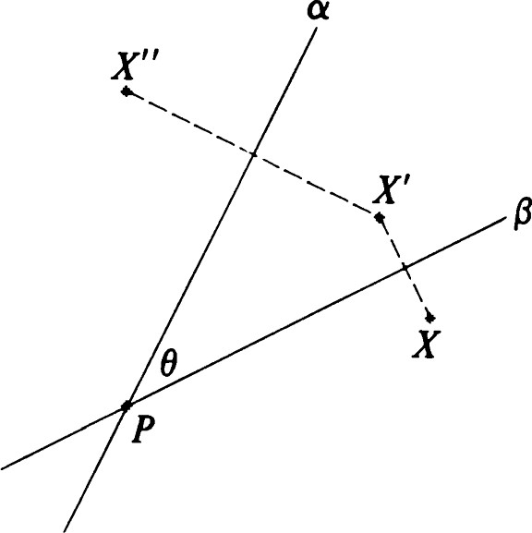

Figure 1.25 OaOß is the rotation about

P by twice e. Three successive positions X, X' , and X" of a typical point are shown.

the identities rot 0 rot = rot (O + 4)) = rot (4) + e) = rot rot 0,

rot (0) (rot 0) —1 hold.

The symbol SO(2) stands for the special orthogonal group of E2 .

Theorem 30.

|  |  |
| --- | --- |
| 1. ref 0 rot d) = ref 2. rot 0 ref 4) = ref |  |

iii. ref e ref  ref = ref (0

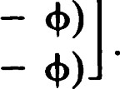proof:

|  |  |  |
| --- | --- | --- |
| cos 20 sin 20 | cos | —sin |
| sin 20 —cos 20 | sin | cos |
| cos (20 — 4) | sin (20 |  |

sin (20 — 4) — cos (20

Equation (ii) is essentially the inverse of (i). Finally, applying (i), we can verify (iii) directly as follows:

ref 0 ref ref = ref e rot — Il')

= ref(e — + +

Theorem 31. The set of all rotations about the origin and reflections in lines through the origin is a group called the orthogonal group and is denoted by 0(2). SO(2) is a subgroup of index 2 in 0(2).

Proof: The following group multiplication table is drawn from the facts we have established.

|  |  |  |
| --- | --- | --- |
|  | ref | rot ß |
| ref e  rot a | rot — 4)  ref + 9 | ref e  rot(a + ß) |

The set of reflections is a coset complementary to the coset SO(2).

Let P be any point. The set of all lines through P is called the pencil of lines through P. We denote by REF(9) = REF(P) the smallest group of isometries containing all Oe, where e e 4. We denote by ROT (P) the set of all rotations about P.

Theorem 32. Let be the pencil of all lines through a point P. Then REF(") 0(2) and ROT(P) SO(2).

Proof: For each Te 0(2), Tp o T o T -p is in REF(P). In fact, Tp ref is a reflection, whereas Tp rot e T -p is a rotation.

It is easy to verify that this provides an isomorphism of 0(2) onto REF (P) and of SO(2) onto ROT(P).

We are now ready to prove the analogues of Theorems 26 and 27 for pencils of concurrent lines.

Theorem 33 (Three reflections theorem). Let a, ß, and -y be three lines

28 through a point P. Then there is a unique line 6 through P such that

= 08. Glide reflections

Proof: If

= Tp(ref e)T-p, 0B = Tp(ref 4)T-p,

and

 = Tp(ref

we should choose 8 so that



In other words, 8 is the line through P with direction vector

(cos(e — + W), sin(e — +

Theorem 34 (Representation theorem for rotations). Let T = OaOß be any member of ROT(P), and let e be any line through P. Then there exist unique lines m and m' through P such that

# T = oeo„ =

Proof: This is similar to the proof for translations.

Glide reflections

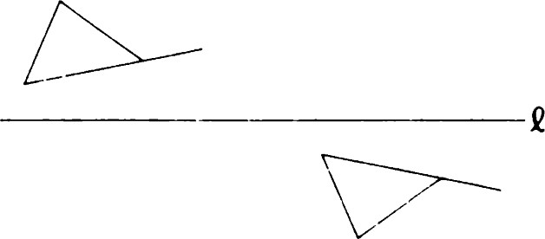We now have three basic types of isometries: reflections, translations, and rotations. A fourth type, the glide reflection, is defined to be a reflection followed by a translation along the mirror. See Figure 1.26. Specifically, if e = P + [v], the glide reflection defined by C and v is given by

where N is the unit vector v-L/lvl. Note that glide reflection with axis and e.its image by a Figure 1.26 A figure

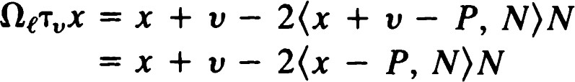

because (v, N) = O. Thus, the reflection and translation making up the glide reflection commute. It will be shown that every isometry is one of the four types: reflection, translation, rotation, or glide reflection. Because  — I is a possibility, each reflection is also a glide reflection. However, glide reflections of this type are said to be trivial.

We have dealt with products of reflections in three lines of the same pencil (parallel or concurrent). As an illustration of the power of the tools we have now developed, we analyze the product of reflections in any three lines.

Theorem 35. Let a, ß, and •y be three distinct lines that are not concurrent and not all parallel. Then OaOßOY is a nontrivial glide reflection.

Proof: Assume first that a meets ß at P. Let e be the line through P perpendicular to -y. Let F be the point of intersection of e and •y. Using the representation theorem for rotations, we know that there is a line m through P such that oa0ß = o„oe and = o„oeo,.

Let n be the line through F perpendicular to m, and let n' be the line through F perpendicular to n. Now oeoy = - HF,

the half-turn about F. As a consequence,



Note that is a translation along n. Because F does not lie on 422, n' and m are distinct. Thus, OaOßOY is a nontrivial glide reflection.

If a does not meet ß but, instead, ß meets •y, apply the same argument to O OßOa = (OaOß00 -l . If we deduce that OYOßOa = TvOe, then QaQßOY = (Tvoe) -l = = T -voc is also a nontrivial glide reflection.

Theorem 36. Let T be a glide reflection, and let Oa be any reflection. Then OaT is a translation or rotation.

Proof: Let e be the axis of the glide reflection T. There are two cases to consider.

CASE 1: e intersects a. Let P be a point of intersection. By the representation theorem for translations, we may write T = OeOaOß, where a passes through P, and both a and 6 are perpendicular to e. Then



But now a, e, and a all pass through P. By the three reflections theorem there is a line c through P such that

ocot. Thus QaT is either a translation or a rotation.

CASE 2: e Il a. Then

OaT= O OOO = 0000

Noting that 6 i e and a i a, we see that OaOa and Oe08 are distinct 30 half-turns. By Exercise 26, Oa Tis a translation.

|  |  |
| --- | --- |
| Definltlon. An isometry that is the product of a finite number of reflections is called a motion. | Structure of the isometry group |

Theorem 37. Every motion is the product of two or three suitably chosen reflections.

Proof: Suppose that a sequence of reflections is given. If the sequence has length greater than three, we choose any four adjacent elements of the sequence. Applying either Theorems 35 and 36 or one of the three reflections theorems, we can write the product of these four reflections as the product of two. This procedure can be continued until fewer than four reflections remain.

Corollary. The group of motions consists of all translations, rotations, reflections, and glide reflections.

# Structure of the isometry group

Our main theorem in this section is the following:

Theorem 38. Every isometry of E2 is a motion.

Proof: Let T be an arbitrary isometry. We consider several cases.

CASE 1: T(O) = 0. In this case we show in the next lemma that T = rot e or ref 0 for some value of e. In other words, T e 0(2).

CASE 2: T(P) = P for some point P. Then T-pTTp is an isometry leaving 0 fixed and is, hence, a member of 0(2) by Case 1. Thus, T = Tp(rot 0)T-p or T = Tp(ref e)T-p. In either case, T is a motion.

CASE 3. T has no fixed points. Let P = T(O). Then T -p o T leaves 0 fixed and is, hence, either rot e or ref e. In any case, T = Tp rot e or T = Tp ref e, so that Tis a motion.

Remark: Case 2 could have been handled as part of Case 3. However, the representation obtained this way is more useful.

We now prove the lemma referred to in Case 1. Although the notion of isometry depends only on distance, the lemma shows that an isometry leaving the origin fixed has a particularly nice algebraic form — it must be linear.

Lemma. If T is an isometry with T(O) = O, then



ii. T = rot e or T = ref e for some e.

Proof:

1. By the polarization identity (see Exercise 29),

= å(Ix 1 2 + l)'1 2 Ix — Y12), å(lTx12 + ITy12 - ITx - Ty12)•

Now

ITxl = d(0, TX) = TX)

= d(O, x) =

Similarly,

ITyl = ly

Also

ITx - Tyl = d(Tx, Ty) = d(x, Y) =

1. Let El = (1, O) and = (O, 1). If x = + X2E2, then {TCI, TE2} is an orthonormal basis for E2 . Hence,

rx = (TX, TEI)TEI + (TX, TE2)TE2.

Using the result of (i), we obtain

Tx = (X, + (X, E2)TE2 = + X2TE2.

Now TEI is a unit vector. Writing

TEI = X I E I + X2 E2,

we see by Theorem 9 and the Cauchy—Schwarz inequality that



Similarly,

 < 1 and ITE11 2 = 2 

so that



As in our discussion of rotations, there is a unique e e (—1T, such that = cos e and = sin e. Now

< TE2, TED  o,

so that

32 -L

In other words,

TE2 — — sin e)E1 + (COS 0)E2).

Writing this in matrix form, we have that either

cos 0 —sin e Xl

 = (rot sin 0 cos e x2

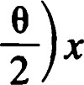or cos e sin e Xl] = (ref sin 0 —cos e x2 for all x e E2 .

Fixed points and fixed lines of isometries

Theorem 39.

1. A nontrivial translation has no fixed points.
2. A nontrivial rotation has exactly one fixed point, the center of rotation. iii. A reflection has a line of fixed points, the axis of reflection. iv. A nontrivial glide reflection has no fixed points.

v. The identity has a plane of fixed points.

Proof: Suppose that T is an isometry with no fixed points. As we have shown in the previous section, T = Tp rot e or T = Tp ref e for suitable P and e. In the first case

Tx = (rot + P

for all x, so that Tx = x if and only if (I — rot = P. But det(l — rot e) — cos + sin2 0

= 2 — 2 cos e = 4 sin2

Now sin2 (0/2) = 0 if and only if rot e = I. Thus, unless rot e = I, the equation (I — rot = P has a solution (see Appendix D), and thus T has a fixed point. Because T has no fixed point, rot e - 1 and T = Tp. Conversely, of course, a nontrivial translation has no fixed point.

We now examine the second case, T = Tp ref e. Observe that T is the product of three reflections. Using Theorem 35, we see that T is a nontrivial glide reflection. Conversely, a nontrivial glide reflection can have no fixed points. For if OeTv is a glide reflection with e = P + [v], and x = Q.e(x + v) then, because O, N) = 0,

But then



so that v = 0.

Thus, an isometry has no fixed points if and only if it is a nontrivial translation or glide reflection. In particular, statements (i) and (iv) hold.

Let T be an isometry with just one fixed point P. From Case 2 of the previous section, Tis a rotation about P or a reflection in a line through P. By Theorem 21 the fixed point set of a reflection consists ot the axis of reflection itself. Hence, T must be a rotation. Conversely, a nontrivial rotation has exactly one fixed point. For if

T = Tp(rot

then x is a fixed point if and only if

x = P + (rot — P);

that is,

(1 — rot — P) = O.

Again, because det (I — rot e) * 0, the only possibility is x — P = 0; that is, x = P. Thus, an isometry has exactly one fixed point if and only if it is a nontrivial rotation. This implies (ii).

Statement (iii) is just Theorem 21, and statement (v)is trivially true. This completes the proof.

Corollary. The fixed point set of an isometry must be one of the following:

i. a point (rotation) ii. a line (reflection) iii. the empty set (translation or glide reflection) iv. the whole plane E2 (the identity).

If e is any line and Tis an isometry, then TC is a line, as we will see in Chapter 2. An isometry induces a bijection T: g--> g of the set g of lines onto itself. If e is a line such that TC = e, we say that e is a fixed line of T. It is useful to classify the isometries of E2 with respect to their fixed lines.

Theorem 40.

1. A nontrivial translation along a line e has a pencil of parallels as its fixed lines. This pencil consists of all lines parallel to e.
2. A half-turn centered at C has the pencil of lines through C as its set of fixed lines. A nontrivial rotation that is not a half-turn has no fixed lines.
3. A reflection 0m has the line m and its pencil of common perpendiculars as its fixed lines.
4. A nontrivial glide reflection has exactly one fixed line — its axis.
5. The identity leaves all lines fixed.

When trying to understand the effect of a particular isometry, determination of its fixed points and fixed lines is a good starting point. These notions and techniques apply in a wider context and will be pursued further in later chapters.

We will defer the proof of Theorem 40 until we have developed more convenient algebraic machinery.

# EXERCISES

1. Prove Theorem 1.
2. Prove Theorem 2.
3. Prove Theorem 3.
4. Fill in the details required to obtain the expression for f(t) in formula (1.1).
5. Show that the result of the corollary to Theorem 4 can be used to obtain the inequality



1. Although P and v determine a unique line e, show that e does not determine P or v uniquely.
2. If C = P + [v] = Q + [w], how must P, Q, v, and w be related?
3. If O < t < 1 and X = (1 — t)P + tQ, and P * Q, show that tIP - QI d(x, Q) = Ix - QI = (1 - t)lP - QI = i—

Use this to find the point X that divides the segment PQ in the ratio r:s. Illustrate using r = 2, s

1. If v is a nonzero vector, show that there are exactly two unit vectors proportional to v.
2. Find an orthonormal pair one of whose members is proportional to
3. i. Find all unit normal vectors to the line 3x + 2y + 10 = 0. ii. Find all unit direction vectors of the same line.

iii. If P = (5, 2) and v = (å, G), find the equation of the line P + [v] in the form ax + by + c = 0.

1. (VI, v2) is a direction vector of a line e, the number a = v2/v1 is called the slope of e, provided that VI * O.
   1. Show that the concept of slope is well-defined.
   2. Show that if e is a line with slope a, the vector (1, a) is a direction vector of e.
   3. Show that the line through P = (Xl, Y'l) with slope a has the equation



1. d(X, C) seems to depend on the choice of P on e and on the unit normal vector N. Show that if N' is another unit normal vector to e and if P' is another point on e, then



1. Let P + [v] and Q + [w] be intersecting lines. Let D be the matrix whose first row is v and whose second row is w. If P — tv = Q + sw is the point of intersection, prove that (t, s) = (P — Q)D -I . Here (t, s) and P — Q are regarded as 1 x 2 matrices. Use this method to find the intersection point in the case P = (1, 5), Q = (3, 7), v = (8, 1),



1. Prove Theorems 17—19.
2. Let e and be parallel lines. Let

 = {4(X + Y)lx e e and Y e m}.

Prove that is a line parallel to e and and lying midway between them. In other words, d(m,

1. The definition of Oe seems to depend on P and N. Show that if P' is another point on e and N' is any unit normal to e, then, for all points x,

(X - P, = (X - P', N')N'.

(Compare with Exercise 13.)

1. Prove Theorem 23.
2. Let be a pencil of parallels as discussed in Theorems 25—27.

i. Show that REF(") is isomorphic to the multiplicative group of 2 x 2 matrices of the form

where the reflection Oa corresponds to the matrix

—1 

and Tx corresponds to

1 

## 36

ii. Observe that TRANS(C) is a subgroup of index 2 in REF(9).

1. Verify the statements in Theorem 28 and its corollary.
2. Prove that
   1. eT(E2) is a normal subgroup of J(E2).
   2. If e is a line, TRANS(C) is not a normal subgroup of J(E2).
3. Let e = P + [v] be a line. Let" = Q + [v]. Show that if = 1, then

oeom = Tw, where w = 2K P — Q, v-L )vL , and

o„oe = T-w.

1. Let Tw be any translation. Let e = P + [WI ] be any line having w as a normal vector. Show that if = P — + [w i l and m' p + + [WII, we have

oeo„ = om,oe = G.

1. Show that the identity is the only rotation that can be described as a rotation about two different points. The unique point P determined by a given nontrivial rotation is called the center of rotation.
2. Verify the statements made in the proof of Theorem 32.
3. i. Show that two distinct reflections Oe and oM commute if and only if -L e.
   1. Let P be any point. Prove that the half-turn about P is given by 

Hpx = —x + 2P for all x e E2 .

* 1. Show that the product of two distinct half-turns is a translation along the line joining their centers.

1. If HI, +12, and +13 are half-turns, prove that

HlH2H3 = H3H2Hl.

1. Describe the product of two glide reflections whose axes are parallel.
2. The polarization identity

= 4(lx12 + ly12 — Ix — Y12)

allows us to express the inner product in terms of lengths. Prove it.

1. We know that each element of J(E2) can be written uniquely in the form Tpa, where a e 0(2) and P e R2 . Show that the function Tpa a is a homomorphism of (E2) onto 0(2). What is the kernel?
2. Prove that the matrix rot e has a nonzero eigenvalue if and only if rot 0 = ±I.
3. Let a be an isometry such that an = I. If n is an odd integer, what can you say about a? Explain.